Lecture 1: Decision Lab

Seqian Wang (260377179), in collaboration with Sulantha Mathotaarachchi and Maxime Parent

# Exercise 1: The reaction time distribution, the reciprobit plot, the activities plot

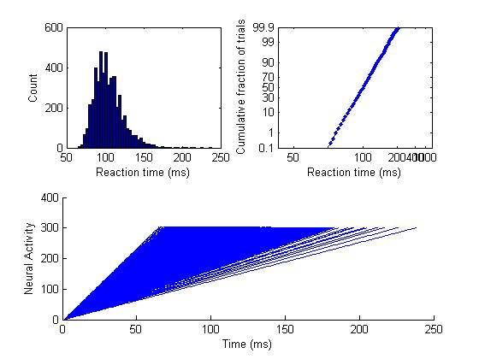

The reaction time distribution plot shows the distribution of the 5000 trials based on the time required for each trial to reach its threshold. The reciprobit plot shows the cumulative reaction time distributions as a percentage of all trials. The plot is accumulative. Finally, the activities plot shows the individual trials, one per line, of neural activity accumulation (reaching threshold 300).

# Exercise 2: evidence=2 (Red) vs evidence=3 (Blue)

[lats2_300,choices,acts] = racemodel(ones(5000,1)*2,300,0.5,0);

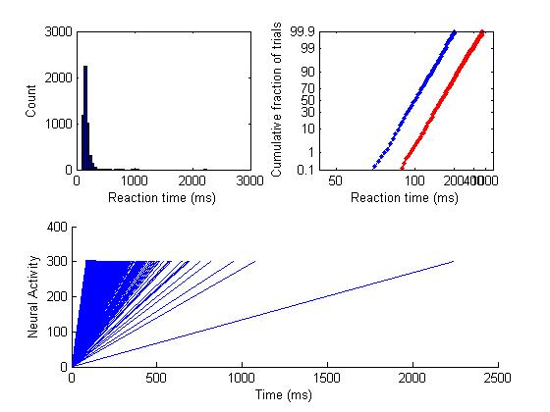

evidence=2 shows longer reaction times than evidence=3, as shown with a right shift in the reciprobit plot. As the evidence or information is weaker (less strong, more ambiguous), it takes more time to reach threshold and decide.

# Exercise 3: threshold=200 (Red) vs threshold=300 (Blue)

[lats2_200,choices,acts] = racemodel(ones(5000,1)*2,200,0.5,0);

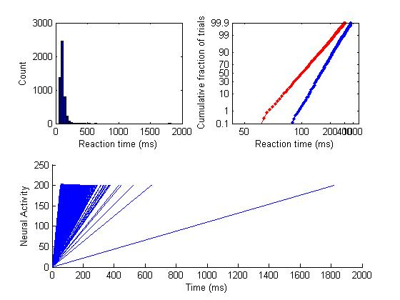

A lower decision threshold is reached faster, and thus threshold=200 has shorter reaction times than threshold=300.

# Exercise 4: trial-to-trial noise=0.2 (Red) vs noise=0.5 (Blue)

[lats2_300_02,choices,acts] = racemodel(ones(5000,1)*2,300,0.2,0);

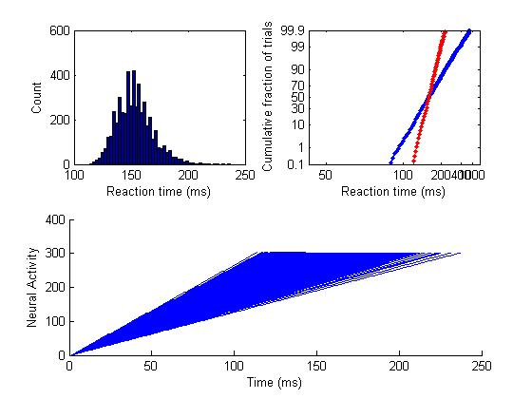

Lower trial-to-trial noise reduces the distribution of reaction times, since there is less outliers and variance. This is translated into a steeper slope in the reciprobit plot.

# Exercise 5: neural noise=1 (Red) vs noise=0 (Blue)

[lats2_300_05_1,choices,acts] = racemodel(ones(5000,1)*2,300,0.5,1);

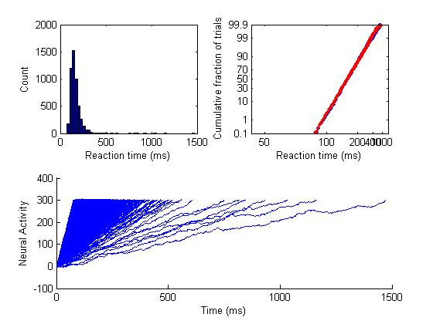

With greater neural noise, there is greater variability within each trial (which cannot be observed here since the neural noise is too low, unlike the next exercise).

# Exercise 6: neural noise=10 (RED) vs neural noise=0 (BLUE)

[lats2_300_05_10,choices,acts] = racemodel(ones(5000,1)*2,300,0.5,10);

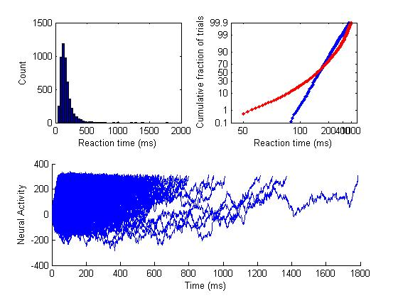

Here, the neural noise is greater and there is more variability and a larger distribution in reaction times (wider histogram, flatter slope in the reciprobit plot). The neural noise has a significant effect within each trial, as can be seen in the activities plot (greater variability within each trial).

# Exercise 7: evidence=3 (Blue) vs evidence=2 (Red)

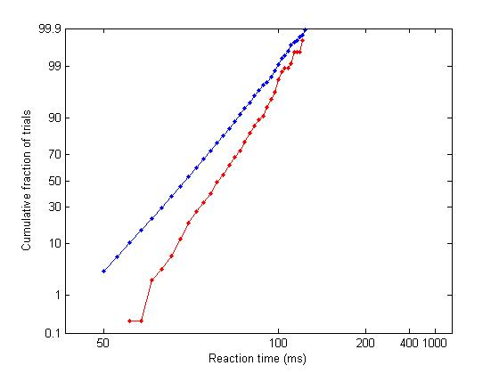

perccorrect = 0.9098

An error (choosing the weaker evidence) is made 9% of the time. This suggests that the evidences are sufficiently distinct, but close enough so that the subject can make mistakes.

# Exercise 8: evidence=3 (BLUE) vs evidence=2.8 (RED)

[lats328_200,choices328_200] = racemodel(ones(5000,1)*[3,2.8],200,0.5,1);

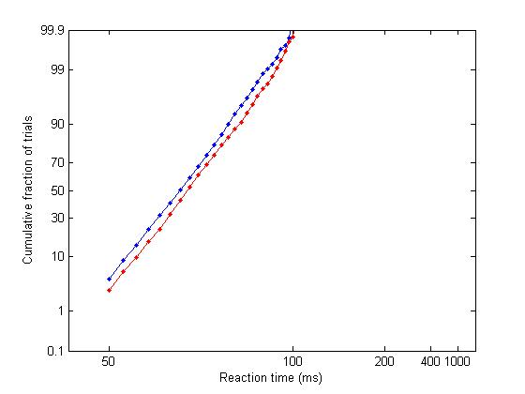

perccorrect = 0.6154

The evidences are much more similar and they are harder to distinguish; an error is made 38% of the time.

# Exercise 9: 100 Head Start (RED) vs No Head Start (BLUE)

% In racemodel.m,

x(t,1:M) = zeros(1,M);

x(t,2) = 100; % Give head start for column (choice) 2

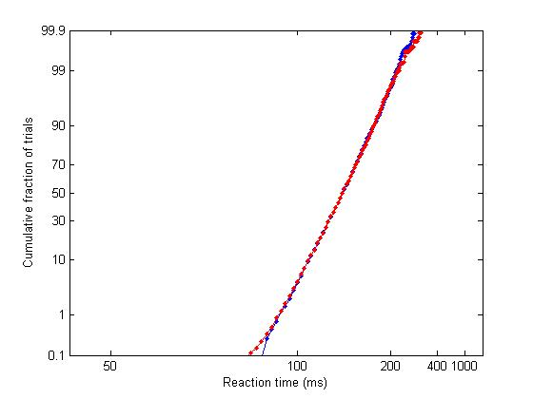

perccorrect = 0.1362

Giving a head start is akin to lowering the threshold (e.g. exercise 3). It will be faster to reach the threshold and to make a decision.

# Exercise 10: Neural Decay (RED) vs NO Decay (Blue)

% In racemodel.m,

x(t,:) = x(t-1,:) + evidence(i,:) + arousal(i,:) + randn(1,M)*neuralnoise; % x(t,2) = x(t,2) - 0.1; % Stimulate decay of 0.1 for column (choice) 2

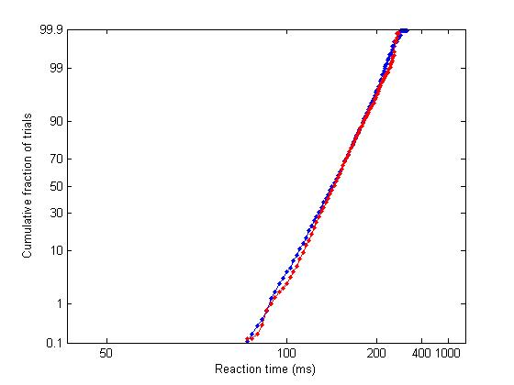

perccorrect = 0.5542

A decay will increase the time needed to reach threshold and will be translated into longer reaction times. It is akin to increasing the threshold; the reciprobit plot will shift to the right.